# **Project: How do I stop and start Amazon EC2 instances at regular intervals using Lambda:**

# **Description :**

In your IT real-time world, we may need to schedule the EC2 instance or RDS instance to restart at regular intervals; it all depends on the needs of your project (it could be hourly, daily, weekly, or monthly). We have multiple ways to do this job.  
For instance, we can use the corn jobs (Linux) or schedule tasks" (Windows) to run the script. and yet another method for performing a manual restart.  
However, in AWS, we have a serverless service to handle this task which is **LAMBDA.**

**Synopsis:**

|  |
| --- |
| Scenario 1: I want to reduce my Amazon Elastic Compute Cloud (Amazon EC2) usage by stopping and starting my EC2 instances automatically. |
| Scenario 2: Create an IAM policy and execution role for your Lambda function |
| Scenario 3: Create Lambda functions that stop and start your EC2 instances |
| Scenario 3: Create Lambda functions that stop and start your EC2 instances |
| Scenario 4: Check the status of your EC2 instances |
| Scenario 5: Create EventBridge rules that run your Lambda functions |

## Short description

You can use AWS Lambda and Amazon EventBridge to automatically stop and start EC2 instances.

To use Lambda to stop and start EC2 instances at regular intervals, complete the following steps:

To use Lambda to stop and start EC2 instances at regular intervals, complete the following steps:

1.    Create a custom AWS Identity and Access Management (IAM) policy and execution role for your Lambda function.

2.    Create Lambda functions that stop and start your EC2 instances.

3.    Test your Lambda functions.

4.    Create EventBridge rules that run your function on a schedule.

1. Create a custom AWS Identity and Access Management (IAM) policy and execution role for your Lambda function.

**IAM policy:** Open IAM service from AWS console and go to policies and click on create policy, and then select EC2 service from the dropdown menu from Visual editor. Expand the write and select the stop instance and start instance actions, then name the policy as **EC2StartStopPolicy** and write the description, click on create policy.

**IAM Role:** Open IAM service from AWS console, go to roles and click on create Role.

Select Lambda from AWS services, Next Attach **EC2StartStopPolicy** and next give name

For role as **EC2startStopRole** and write description, then click on create role.

1. Create Lambda functions that stop and start your EC2 instances.

**Lambda functions:** Openlambda from AWS services, go to Functions and click on create function button, select python3.9 runtime and give name as **StartEc2lambdaFun**, and select Existing role as we created before.

Write python code to start the EC2 instance in code tab and save it, create a test event for executing the start function. Repeat the same process for stopping the instance.

3.    Test your Lambda functions.

Click on the Test button, then the start function will execute the code. Go to EC2 and check whether the Ec2 instance is starting or not.

Click on Test button, then the stop function will execute the code. Go to EC2 and check whether the Ec2 instance is stopping or not.

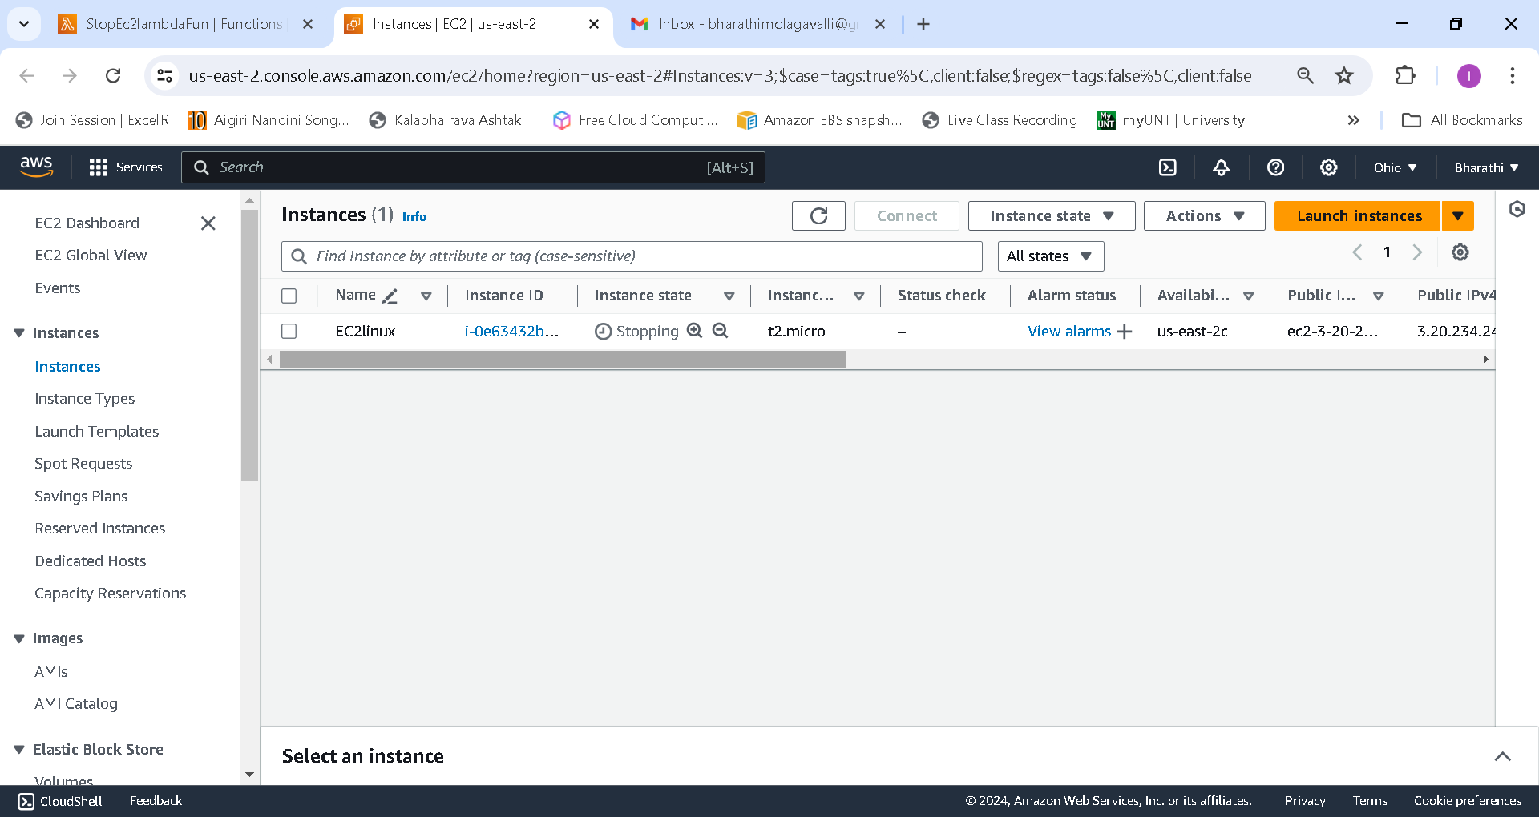

4.    Create EventBridge rules that run your function on a schedule.

Go to Amazon EventBridge and create rules for start and stop and Give names as StopEBrule and StartEBrule. Select target Lambda, invoke the lambda function and choose execution rule. Select Schedule type and write corn expression for time and click on create schedule. Lastly, go to cloudwatch log groups and check the log events for EC2 instance start and stop actions.



